**FALL 2025 LC/LX Offerings Advising Sheet (3 pages)**

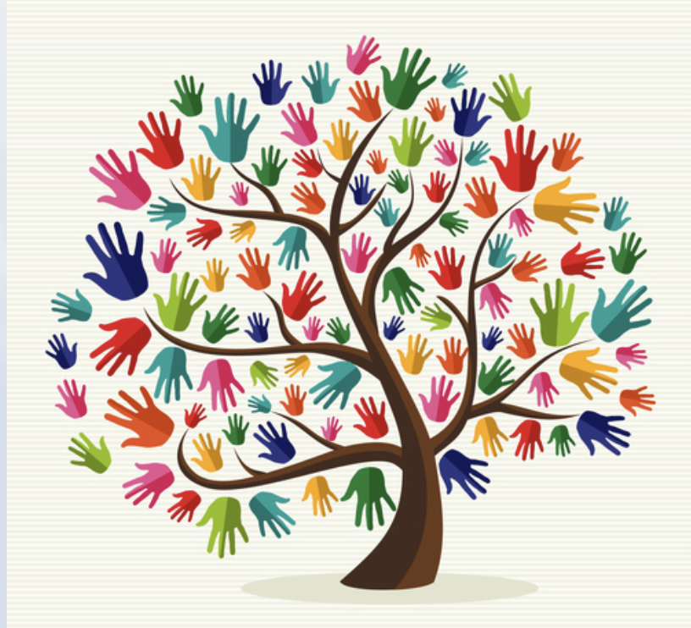

**Regarding course modalities:**

**● Online = Fully Online**

**● OC = On Campus**

**● HB = Hybrid (some parts of course Online, some parts OC)**

**Note: To register for an LC, you must register for each of its courses individually (2**

**CRN #s).**

**Who should take LC?**

* LCs are for EVERYONE!
* need to complete **Gen Eds required** in **all majors**
* need/want confidence, build on classroom connections, build skills and preparation

**for career & all transfer colleges**

* help build communication skills, **speaking in classes** to build confidence and success
* need/want skill building in analytical thinking and writing, prepares **for upper-level courses**
* good for **first-year students, transfer students**
* interest in social justice issues/grassroots activism
* Pre-reqs of all courses included below
* To register for LCs, you will need to **use both CRN#s of the paired courses**
* **All in a supportive environment that builds on student belonging**!

**Learning Communities for Fall 2025**

**-LC 101.01: The Handmaid's Tale: Could It Happen Here** with Lisa Mahon & Melissa Weise

SOC 110.07 (30800) & ENG 102.08 (30799) on Tuesdays & Thursdays 9:30 - 12:15 on campus

**Description:**  How does sociology influence the experiences of those with oppressed identities (women, BIPOC, LGBTQ+ folks) in today’s America?  How are those identities expressed in writing?  How do changes in social policy impact our personal lives?  How does society define who gets to be oppressed?  Women are oppressed in The Handmaid's Tale, but what would it be like to be transgender, disabled, or Black in Gilead?  We will explore all of the different identities one could have in the society of Gilead and how their policies could impact the experiences of individuals.  Ultimately, we will consider social interventions that would create societies that ensure that everyone has universal access to basic human rights such as happiness and safety. This LC will include the book The Handmaid’s Tale by Margaret Atwood, select episodes from the Hulu series, newspaper articles, interviews, excerpts from documentaries, and poetry to explore our topic from a variety of perspectives.

**Prerequisite**: Undergraduate level ENG 101 Minimum Grade of D- or Undergraduate level ENG 101 Minimum Grade of T

**-LC 102.01: Our Ancestors’ Wildest Dreams: The First Gen Student - A Collaborative Exploration** with S. Bates & R. Gutiérrez ENG 101.18 (30801) & LAX 110.02 (30802) MWF 10-11 & MF 11-12:15 on campus

**Description**: First-gen students will dive into their U.S. experiences through a diverse, interdisciplinary lens. Centered in our collaborative Writing Community, we will dissect historical, political, cultural, racial, and social contexts that inform the first gen experience. Through expressive experimentation and collaborative learning, we will enhance our writing and reading skills. Emphasizing critical analysis of unique perspectives, including our own, we will explore literature and cultural studies as a means for decoding power dynamics and their impact on human lives. Students will read and analyze literary, philosophical, political, and historical works before forming and entering the conversation with their own bold perspective.  **Prerequisite: Eligibility to ENG 101**

**-LC 104.50 “Pa’lante Compañeros:” Social Justice Movements in Black and Brown Communities** with M. Clinton & TBA HIS 115.51 (30805) & LAX 111.51 (30806) on Tuesdays & Thursdays 6-9 pm (Evening Class/on campus)

**Description**: This Learning Community will analyze the achievements of various Black and Brown social movements. We will explore struggles for social justice in various Black and Brown communities in both the United States and throughout the Americas. We will give particular attention to the labor movement and to movements in Cuba, Jamaica, Latin America, the U.S. Southwest, Oakland, and Holyoke. The Learning Community will review the historical, political, cultural, racial, and social underpinnings of these revolutionary movements, exploring how various movements influenced each other and their strategies and tactics for community and labor organizing. Students will read and analyze literary, philosophical, political, and historical works; view and critically analyze movies, documentaries, and other audiovisual sources as types of secondary historical sources; and gain experience in historical research using primary sources. What can we learn from the aspirations of the movements we study, both in terms of their achievements and from those of their aspirations that have yet to be fulfilled? **Prerequisites: Eligibility to ENG 101**

**-LC105.01 In the Picture: Cultural Representations by Children's Illustrators** with A. Graziano & D. Lovegrove EDU 100.01 (30807) & COM 121.03 (30808) on Tuesdays & Thursdays 9:30 -12:15 on campus

**Description**: Examining cultural symbols in classical and contemporary children’s books will help us survey how cultural representation has changed throughout America’s educational system, and how award-winning children’s book illustrators have impacted the nature and value of education in society and our methods of communication. Analyzing how symbols influence our thinking and behavior will support our exploration of historical, philosophical, social, and political issues in early childhood through secondary education. How does communication impact the role of schools in maintaining, perpetuating, and influencing culture, both nationally and internationally? A ten-hour field study in an educational setting is required. **NOTE**: Students enrolled in EDU courses may be subject to CORI/SORI background checks. **Prerequisites: None**

-**LX 101.01 The US Border: Whose “Rites of Passage?”** with U. Idem & S. Gilleman

ESL 155.66 (30810) & ENG 095.67 (30811) MW 9-10:50 & M 11-12:15 On campus & ONLINE

**Description**: In this course, students will have the opportunity to develop English language skills while studying the varied aspects of immigration. What are the push and pull factors for coming to America? What specific historical, political, economic, social, and religious reasons bring immigrants to the US border? Who has the “rites” of passage into the US? What challenges do immigrants face in their attempts to integrate? What culture shocks do they experience? What are their own attitudes and assumptions about immigration? Students will collaboratively attempt to answer these questions through the lens of their own identities, world experiences, textbooks, fiction, essays, oral interviews, film, or community events.

**Prerequisites:** Recommendation of ESL 143 instructor, ENG 085, placement test, or permission of the LC instructors

Faculty of these LC courses welcome conversations with students and can email them directly or connect with the LC Coordinator, Raul Gutierrez @ rgutierrez@hcc.edu

LC student testimonials: They are for everyone!

<https://www.youtube.com/watch?v=SGQ8YWL1eHU&t=15s>

**For any questions or concerns, contact Irma Medina, Director of Integrative Learning**

[www.hcc.edu/il](http://www.hcc.edu/il)